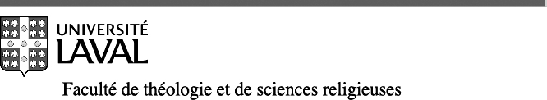 | 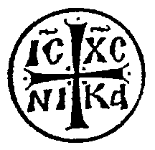
______________________________________________________________________________
CERTIFICATE IN ORTHODOX THEOLOGY
THL-1236 Winter ∕ Hiver 2022

FUNDAMENTALS OF ORTHODOX SPIRITUALITY /
INTRODUCTION À LA SPIRITUALITÉ ORTHODOXE
Prof. Dr Paul Ladouceur
123thabor@gmail.com
Online, live sessions Mondays 7:00-9:30 p.m. ET
starting Monday, January 10, 2022
Spirituality is primarily faith lived in the search for God and the experience of God, which the ascetic Fathers called theologia, beyond "theology" as theoretical knowledge of God. This course explores Orthodox spirituality from thematic and historical perspectives, drawing on the principal personalities and writings that contributed to its development to the 14th century.
From a consideration of the goal of Orthodox spirituality as union with God or deification (theosis), the course will examine the contributions of the Old and New Testament; the experience of early Church; monasticism; ancient philosophy; liturgical and sacramental elements; the mystical and contemplative aspects; and patristic theology.
On this basis, the Fathers developed an ascetic theology which includes such key notions as the "passions"; the stages of temptation and sin; repentance or conversion (metanoia); the concurrence of divine and the human elements in the spiritual life (synergy); and the roles of the mind (nous), the heart and the guarding of the heart (nepsis) in the spiritual life. These elements of spirituality constitute a framework for the practice (praxis) of the spiritual life: the acquisition of virtues, particularly the fulfillment of the commandment of love; communal or liturgical prayer; participation in the sacraments, especially the Eucharist; personal prayer, fasting; Biblical and spiritual reading; and spiritual direction.
The course examines these themes in the framework of the traditional stages of the spiritual life: purification, illumination and perfection, signposts towards the goal of the spiritual journey, the Kingdom of God, which is both present here and now, and yet is hoped for, not yet realised.
Throughout the course, themes will be illustrated and deepened by the readings from the great classics of Orthodox spirituality.
Videos of lectures and most course material will be in English. Questions and discussion in online sessions, as well as oral presentations and written assignments, may be in English or French.

